Final Project: Sports Participation and First-Grade Reading Achievement

Introduction
This project examines whether participation in organized sports is associated with first-grade reading achievement using data from the Early Childhood Longitudinal Study—Kindergarten Class of 2010–11 (ECLS-K:2011). Although sports participation is often linked to academic success, the causal effect is unclear because participation is selective: more advantaged students and stronger readers may be more likely to join sports programs, and some school programs require minimum grades to participate. I address this question using two approaches required for the project: (1) covariance adjustment with hierarchical linear models (HLM), and (2) propensity score stratification followed by a final HLM in HLM software.

Data and Variables
The analytic sample includes 12,436 students nested in 817 schools. The outcome variable is Read1, a first-grade reading test score (M = 78.91, SD = 23.74). The treatment variable is Sports, a binary indicator of organized sports participation (37.1% participated). Student-level covariates include gender (Male), racial minority status (NonWhite), a composite SES measure, arts participation (Arts), kindergarten reading score (ReadK), and age in months (Age). School-level covariates include Catholic school (Catholic), other private school (OthPriv), and kindergarten enrollment (SchKEnrl), with public schools as the reference group.
N | Schools | Mean Read1 | SD Read1 | Sports Rate
12,436 | 817 | 78.91 | 23.74 | 37.1%

Analytic Approach
Because students are nested within schools, I estimated two-level hierarchical linear models with students at Level 1 and schools at Level 2. All covariance-adjustment models were estimated in R using lme4/lmerTest. The final propensity score stratified model was estimated in HLM 7 using the PS-stratified Level-1 file (eclsk_ps_hlm.sav) linked to schools by S1_ID.

I. Covariance Adjustment

A. Naive Model (No Covariates)
Model specification:
Level-1: Read1 = π0 + π1(Sports) + e
Level-2: π0 = β00 + u0; π1 = β10 + u1
Combined: Read1 = β00 + β10(Sports) + u0 + u1(Sports) + e
Only Sports is included as a predictor, and both the intercept and Sports slope are allowed to vary across schools: (1 + Sports | S1_ID).
Effect | Estimate | SE | t | p
Intercept | 77.23 | 0.44 | 174.39 | < .001
Sports | 4.04 | 0.44 | 9.10 | < .001

Random effects:
Component | Variance | SD
School intercept | 106.2 | 10.31
School Sports slope | 11.5 | 3.39
Residual | 455.7 | 21.35

Interpretation. The intercept of 77.23 is the estimated average first-grade reading score for non-participants (Sports = 0) in an average school. The Sports coefficient of 4.04 indicates that, in the naive model, sports participants scored about 4.04 points higher than non-participants, holding the school context at its average (p < .001). The significant school intercept variance (SD = 10.31) shows that average reading achievement differed substantially across schools. The random slope variance for Sports was positive but did not reach conventional significance at α = .05, suggesting limited evidence that the sports–reading association varied across schools. In plain language, the naive model suggests a sizable sports advantage, but this estimate is likely inflated by selection because it ignores student and school differences.

B. Covariate-Adjusted Model
Model specification:
Level-1: Read1 = π0 + π1(Sports) + π2(Male) + … + π9(SchKEnrl) + e
Level-2: π0 = β00 + u0; all π coefficients for Level-1 predictors are fixed (no random slopes)
Combined: Read1 = β00 + β10(Sports) + … + β90(SchKEnrl) + u0 + e
All student- and school-level covariates are included with fixed slopes. Only the school intercept is random: (1 | S1_ID).
Predictor | Estimate | SE | t | p
Sports | 0.97 | 0.30 | 3.22 | .001
Male | −1.15 | 0.27 | −4.31 | < .001
NonWhite | −1.02 | 0.32 | −3.14 | .002
SES | 2.53 | 0.21 | 12.21 | < .001
Arts | 1.07 | 0.39 | 2.75 | .006
ReadK | 1.23 | 0.01 | 118.91 | < .001
Age | −0.05 | 0.03 | −1.72 | .086
Catholic | −0.04 | 0.68 | −0.06 | .950
OthPriv | 1.03 | 0.75 | 1.37 | .170
SchKEnrl | −0.00 | 0.01 | −0.74 | .458

Interpretation of the treatment effect. After adjusting for observed covariates, the Sports coefficient fell from 4.04 to 0.97 (p = .001). Sports participants scored about one point higher in first-grade reading than otherwise similar non-participants.
Why the treatment effect changed. The large drop from 4.04 to 0.97 suggests that much of the naive association was due to observed confounding. Students with higher SES and stronger kindergarten reading scores were more likely both to participate in sports and to score higher on Read1. Once these differences were controlled, the sports effect was much smaller.
What else I learned from the model. Kindergarten reading (ReadK) was the strongest predictor of first-grade reading (b = 1.23, p < .001). SES was also strongly positive (b = 2.53). Male students and racial minority students scored lower on average after adjustment. Arts participation was positively associated with reading (b = 1.07). School sector and enrollment were not statistically significant once student covariates were included.

II. Propensity Score Stratification
The goal of propensity score stratification is to estimate the sports–reading association within groups of students who have the same, or nearly the same, probability of sports participation.

A. Building the Propensity Score Model
Model specification:
Level-1: logit(P(Sports = 1)) = η
η = γ00 + γ10(Male) + γ20(NonWhite) + … + γ90(SchKEnrl)
Level-2: γ00 = δ00 + v0 (random intercept for school)
I estimated a two-level logistic regression model predicting Sports from all pre-treatment covariates, with a random intercept for school (S1_ID). Predicted log odds of treatment (the linear predictor from the logistic model) were saved for each student and converted to propensity scores (predicted probabilities).
Selected fixed effects from the two-level logistic model:
Predictor | Log-odds coefficient
Male | 0.93
NonWhite | −0.89
SES | 0.63
Arts | 0.25
ReadK | 0.006
Age | 0.023
Catholic | 0.37
OthPriv | −0.27
SchKEnrl | 0.0003 (n.s.)

Male, NonWhite, SES, Arts, ReadK, Age, Catholic, and OthPriv were significant predictors of sports participation. These results confirm that treatment is not random and justify propensity score adjustment.

B. Common Support
I examined the distribution of propensity scores for treated (Sports = 1) and control (Sports = 0) students. Although sports participants tended to have higher propensity scores, there was substantial overlap between groups. To ensure common support, I removed students with propensity scores below 0.05 or above 0.95. This removed 48 students (0.4% of the sample), leaving 12,388 students for stratification.
Why this step is necessary. Without common support, treated and control students at extreme propensity scores are not comparable: there may be treated students with very high propensity scores but no similar control students (or vice versa). Estimating treatment effects in those regions requires extrapolation and can produce biased estimates. Restricting the sample to the region of overlap ensures comparisons are made among students with similar probabilities of treatment.
Figure 1. Propensity score distribution by sports participation status.
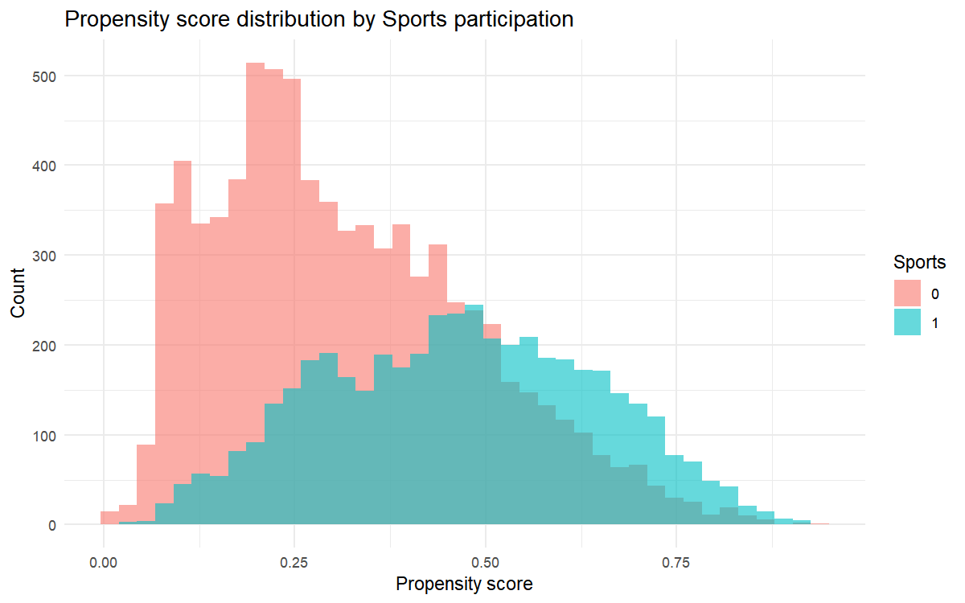

C. Stratification
Students in the common-support sample were sorted by propensity score and divided into five equal-sized strata using quintiles. Stratum sizes were approximately 2,477–2,478 students per stratum. Stratum 1 served as the reference category in the final model; strata 2–5 were entered as dummy indicators (strata2–strata5).

D. Balance Diagnostics
I assessed balance between treated and control students using absolute standardized mean differences (|SMD|) on all covariates, both overall and within each stratum.
Balance criterion | Result
Within-stratum |SMD| below 0.10 | 80.0%
Within-stratum |SMD| below 0.20 | 88.9%

Quality of balance. After stratification, 80.0% of within-stratum comparisons had |SMD| below 0.10 and 88.9% below 0.20, indicating good balance by conventional standards (|SMD| < 0.10 is ideal; |SMD| < 0.20 is acceptable). This means that, within each stratum, treated and control students were much more similar on observed covariates than in the full sample. Improved balance reduces bias from observed confounding, although it does not eliminate bias from unmeasured confounders.

E. Final Analytic Model (HLM)
Model specification:
Level-1: Read1 = π0 + π1(Sports) + π2(strata2) + … + π5(strata5) + e
Level-2: π0 = β00 + u0 (random intercept only)
This model was estimated in HLM 7 using the PS-stratified Level-1 file linked by S1_ID.
Effect | Estimate | SE | t | p
Intercept (Stratum 1) | 70.81 | 0.55 | 127.84 | < .001
Sports | 1.08 | 0.44 | 2.45 | .014
Stratum 2 | 4.74 | 0.63 | 7.48 | < .001
Stratum 3 | 7.85 | 0.66 | 11.93 | < .001
Stratum 4 | 9.76 | 0.68 | 14.37 | < .001
Stratum 5 | 16.14 | 0.72 | 22.31 | < .001

Interpretation. Within propensity score strata, sports participants scored about 1.08 points higher on first-grade reading than comparable non-participants (p = .014). This estimate is much smaller than the naive estimate (4.04) and similar to the covariate-adjusted estimate (0.97), suggesting that most of the raw difference was due to selection on observed characteristics. The significant stratum coefficients reflect higher average reading scores in higher propensity-score strata, which is expected because students with higher propensity scores tend to have higher SES and kindergarten achievement.

E. Causal Interpretation
A causal interpretation of the sports effect would require several assumptions: (1) no unmeasured confounding— all variables that affect both sports participation and reading are observed and correctly modeled; (2) common support— treated and control units have overlapping propensity scores; (3) correct model specification; and (4) stable unit treatment value (SUTVA)— one student's sports participation does not affect another student's reading.
Assessment. Common support and balance on observed covariates appear reasonable, so bias from observed confounding is likely reduced. However, the no-unmeasured-confounding assumption is questionable. Factors such as parental involvement, student motivation, neighborhood resources, health, and school encouragement of extracurricular activities may affect both sports participation and reading but were not measured. Because sports programs often require minimum grades, reverse causality is also possible. Therefore, the results should be interpreted as evidence of an association rather than definitive proof of a causal effect.

F. Sensitivity Analysis
Following the course sensitivity approach, I evaluated whether the estimated sports effect is robust to potential unobserved confounding. I selected kindergarten reading (ReadK) as a powerful predictor of the outcome (b = 1.23 in the adjusted outcome model) and computed the mean difference in ReadK between sports participants and non-participants (Δ = 3.55 points). The estimated plausible bias from an unobserved confounder as strong as ReadK is:
Plausible bias = |bReadK| × |ΔReadK| = 1.23 × 3.55 ≈ 4.37 points.
The PS-stratified sports coefficient (1.08) and covariate-adjusted coefficient (0.97) are both smaller than this plausible bias (4.37). This means that if an unobserved confounder as strongly related to reading as kindergarten reading score were omitted from the model, it could explain the remaining estimated sports effect. The naive estimate (4.04) is close to this benchmark, which is consistent with the view that much of the raw association was confounding. Thus, the small adjusted effects are not robust to unobserved confounding of ReadK-like strength, and causal claims should be made cautiously.
Model specification sensitivity (comparison across approaches):
Model | Sports coefficient | SE | t | 95% CI
Naive HLM | 4.04 | 0.44 | 9.10 | [3.17, 4.91]
Covariate-adjusted HLM | 0.97 | 0.30 | 3.22 | [0.38, 1.56]
PS-stratified HLM | 1.08 | 0.44 | 2.45 | [0.22, 1.95]
PS-stratified + adjusted HLM | 0.96 | 0.30 | 3.24 | [0.38, 1.54]

The three adjusted estimates (0.97, 1.08, and 0.96) are very similar, suggesting that the conclusion of a small positive association is moderately robust to model specification. The large difference between the naive and adjusted estimates confirms that confounding was substantively important.

III. Conclusion
Overall, sports participation was positively associated with first-grade reading achievement. The naive HLM suggested a large 4-point advantage for sports participants, but this estimate fell to about 1 point after covariate adjustment and propensity score stratification. This pattern indicates that much of the raw difference in reading achievement reflected pre-existing differences between students rather than sports participation itself.
Comparison of methods. Covariance adjustment directly controls for observed confounders in the outcome model and is straightforward to implement in HLM. Its main advantage is efficiency: it uses the full sample and provides interpretable coefficients for all covariates. Its limitation is that it depends heavily on the correctness of the outcome model and does not explicitly evaluate balance between treated and control groups.
Propensity score stratification improves comparability by grouping students with similar treatment probabilities and checking balance with SMDs. Its advantage is transparency about selection and balance; the stratification step makes it clear whether treated and control students are comparable on observed covariates. Its limitations include sample loss from common-support trimming, reliance on the propensity model, and the need to model strata in the final outcome analysis.
Both methods converged on a similar conclusion: a small but statistically significant positive association between sports and reading after addressing observed selection. However, sensitivity analysis showed that the adjusted effects are not robust to unobserved confounding as strong as kindergarten reading achievement. Future research with richer measures of family and student characteristics would be needed to strengthen causal inference.

